**PIZZA SALES QUERIES**

**A. KPI’s**

**1. Total Revenue:**



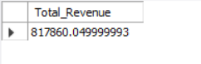

**2. Average Order Value**

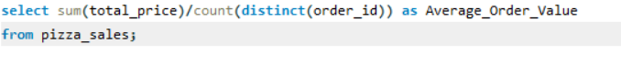

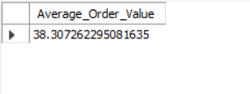

**3. Total Pizzas Sold**





**4. Total Orders**





**5. Average Pizzas Per Order**





**B. Daily Trend for Total Orders**

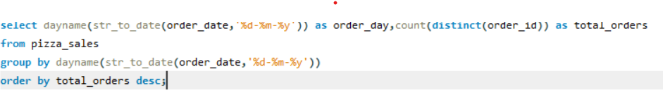

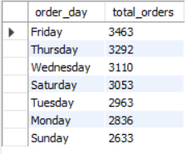

**C. Hourly Trend for Orders**

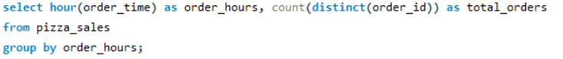

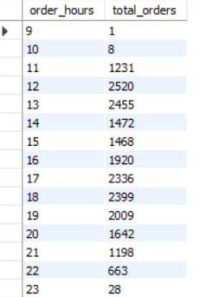

**D. % of Sales by Pizza Category**



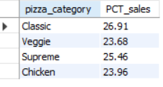

**E. % of Sales by Pizza Size**



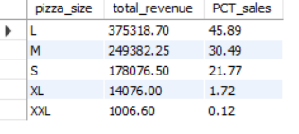

**F. Total Pizzas Sold by Pizza Category**

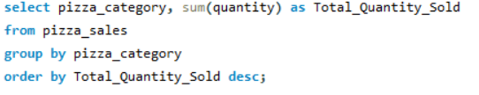

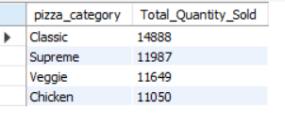

**G. Top 5 Best Sellers by Total Pizzas Sold**

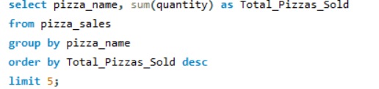

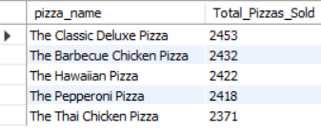

**H. Bottom 5 Best Sellers by Total Pizzas Sold**

